# Homework: HTML5 Tables

## Simple Table

Create an HTML page like the image below (100% accuracy is not required).

**

Hint: Use table for the layout. Link the Chochev logo with https://chochev.eu.

*Note: Using tables for creating website layout is deprecated; we use this approach only to practice the making of tables.*

## Exam Results

Create an HTML table like the image below (100% accuracy is not required). Use semantic table tags: **<thead>**, **<tfoot>**, **<tbody>**, etc.

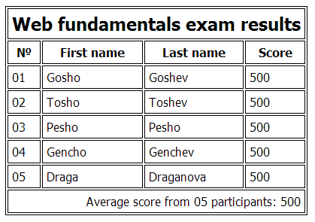

## Nested Tables

Create an HTML table like the image below by using nested table (100% accuracy is not required). Link the SoftUni logo with https://chochev.eu. Make the link open in new tab.



*Hint: Use tables and buttons.*

## ***Calculator

Create a simple **fully functional calculator**, similar to the image below. You can use styles by your liking.

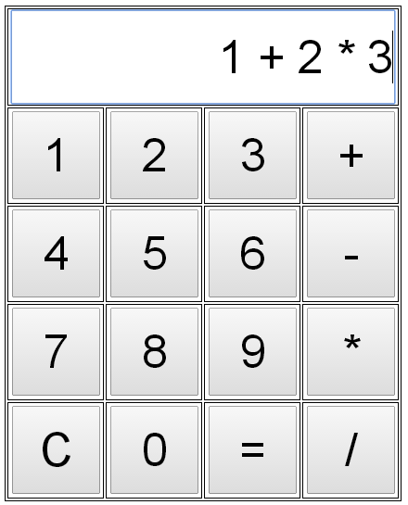

*Hint: Use JavaScript to achieve the functionality of the calculator. You may calculate the entered expression by the* ***eval(expression)*** *function in JavaScript.*